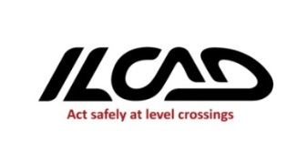
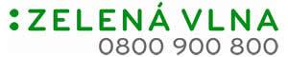

Press Release
Bratislava, 7 May 2013

7 MAY 2013 – INTERNATIONAL LEVEL CROSSING
AWARENESS DAY

Železnice Slovenskej republiky (ŽSR) in cooperation with Ministry of Transport, Construction and Regional Development of The Slovak Republic (SR), Ministry of Interior of SR, The Police of SR, Zeleznicna spolocnost Slovensko (ZSSK - Slovak rail passenger operator) and media project partner Zelená vlna RTVS (Green Wave of The Radio and Television of Slovakia) are jointly involved in the International Level Crossing Awareness Day also in its edition of 2013. This year with the project´s headline: Pedestrian´s Safety at Level Crossings.

ŽSR is involved in the International Level Crossing Awareness Day for the fifth time and picks up to annually implemented preventive-safety actions aimed at road users while providing them with information on safe behaviour at and around level crossings and thus preventing accidents at level crossings.

This year ŽSR within the focus at pedestrians at level crossings decided to undertake a simulated collision of a human dummy and a train at selected level crossing. Through a short DVD spot the demonstration will be available to the public and the media with the aim to make public aware of extreme seriousness, the tragic dimension and dangerous situations that can happen at railway level crossing in a single moment of inattention, and also related aftermaths of such tragic accident in terms of the loss of life, severe injuries, enormous property damage. With this demonstration we would like to alert the road users to think twice when passing through a level crossing, to act cautiously and adhere to the provision of the Act on Road Traffic.

National actions prepared as a part of the International Level Crossing Awareness Day 2013:

- Simulated collision at selected level crossing.

ŽSR prepared on 7 May 2013 at selected level crossing at Kamenna cesta in Trnava simulated collision between human dummy and motive power unit (locomotive) followed by a capture of dummy pedestrian standing in the immediate vicinity of a level crossing. Collisions will be performed at the speed of 30 kph and 80 kph respectively (track speed of trains in given section).
In the case of a collision the pedestrian dummy is life-size, made of plastic, attached to the level crossing at a pedestrian crossing. At speed of 30 kph it is possible to observe effects of this devastating collision. Train driver report the accident via calling 112 of the Integrated Rescue System and announce the level crossing identification number. As for the second case the dummy is placed in immediate vicinity of rails directly at level crossing while due to a pressure wave the dummy is caught by a train.

Technical parameters of the locomotive used for a simulated collision:
Series: HDV 240 (Motive Power Unit No. 240)
Nickname: Laminátka
Max. speed (kp.h-1): 120 kph
Bogie wheelbase (m): 2,8
Weight (t): 85
Total performance (kW): 3 080 permanent / 3 200 hourly

The level crossing where the simulated collision is performed is equipped with unique identification number SP 0452 and is located at km 2.720 at single-track line Trnava – Kúty in the residential area of Trnava and is at-grade intersection with road at Kamenná cesta Street. In terms of STN P 342651 it is protected with signalized railway crossing safety installation without gates with active signalization, PZS 3 type AŽD-RE and is supplemented with pedestrian crossing.
For 24 hours regularly 22 passenger trains and 7 freight trains passes through the level crossing

- Billboards in Slovakia

ŽSR as a part of the ILCAD 2013 has prepared billboard information-precautionary campaign. From 1 May to 31 May at 50 selected places around Slovakia billboards are placed, which informs on what to do in case of accident or failure at and around level crossings. ŽSR intends to alert and make people aware of rolling out an unique identification number of level crossings, this is in practice since summer 2012.

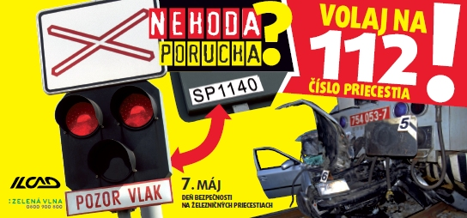

- Checks at Level Crossings

Like in previous years, also during this year´s May in cooperation with The Police of SR and The Railway Police monitoring actions aimed at control of adhering to traffic rules and safety when driving over crossing will be undertaken – maximal allowed speed, proper driving across a crossing, etc.

- Zhelko´s Kindergarten

Also this year´s the mascot of ŽSR for level crossing safety is railwaymen hedgehog, whose been given name „Zhelko“. ŽSR´s mascot is used for a publication aimed at kindergarten and primary school children named Zhelko´s Kindergarten. With attractive colouring and images, the book provides children with basic situations in a playful way, occurred at railways as well as explanations how to act in certain situations. The main characters of the book are railway hedgehog Zhelko and a playful rabbit, who is tutored by Zhelko what is wrong and why. Publication reported a huge success among educators, parents and children and is freely available at www.zsr.sk.

Information provided by:
Martina Pavliková, spokesperson, ŽSR
Contact:
Tel.:0903-244 460, E-mail: pavlikova.martina@zsr.sk

